**EMAIL SERVER USING AWS**

**ABOUT :**

This is the small project on creating email server using AWS for sending and receiving Email without using the Gmail service. For this we will be using SES

(Simple Email Service) for sending and receiving Emails.

**BASIC STEPS:**

1. Sign in to AWS management console and search SES in the search bar

<https://console.aws.amazon.com/ses/>

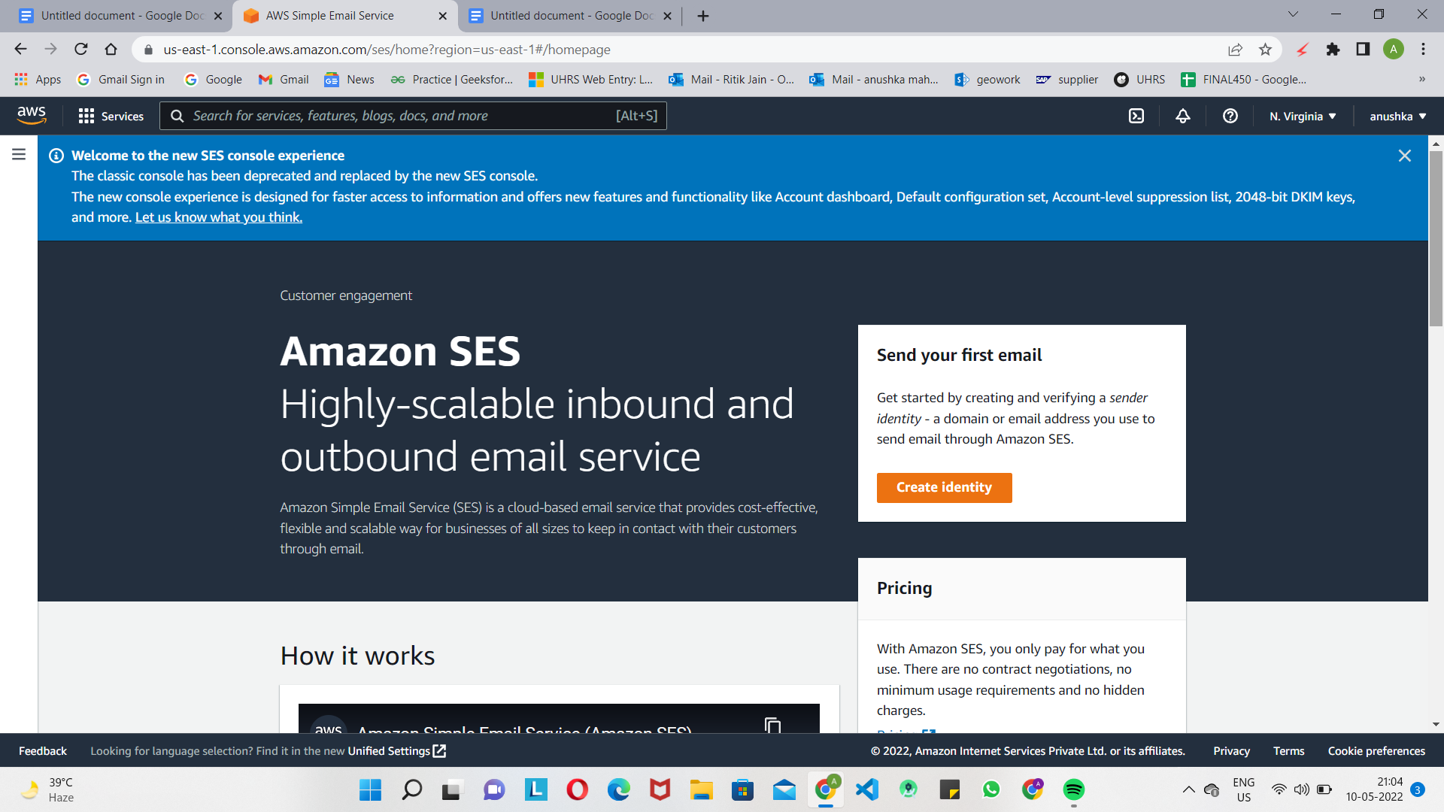

1. Create identity :

In Amazon SES, a verified identity is a domain or email address that **you use to send or receive email.** Before you can send an email using Amazon SES, you must create and verify each identity that you're going to use as a "From", "Source", "Sender", or "Return-Path" address.

In Amazon SES, you can create an identity at the domain level or you

can create email address identities. These identity types aren’t mutually

exclusive. In most cases, creating a domain identity eliminates the need for

individual email address identities, unless you want to apply custom

configurations to a specific email address.

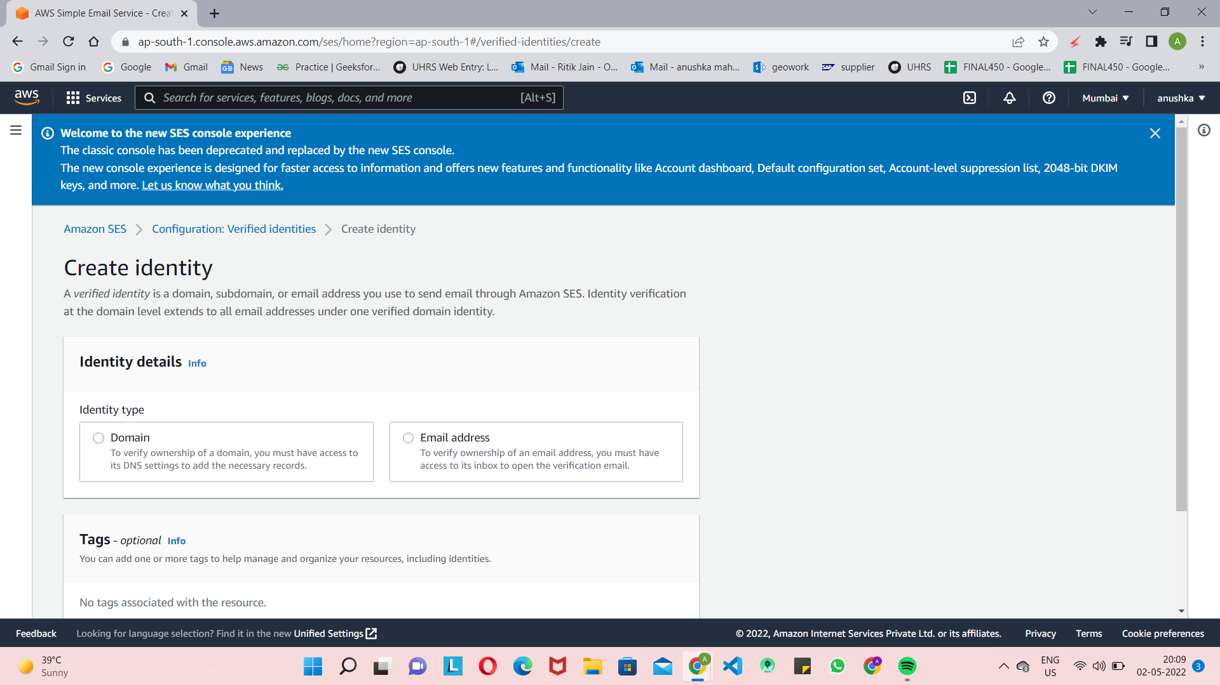

Creating and verifying an email address identity is the fastest way to get started in Amazon SES, but there are benefits to verifying an identity at the domain level. When you verify an email address identity, you’re only able to send from that email address. When you verify a domain identity, you can send email from any subdomain or email address of the verified domain without having to verify each one individually. For example, if you create and verify an identity for example.com, you don't need to create separate identities for a.example.com, a.b.example.com, user@example.com, user@a.example.com, and so on.

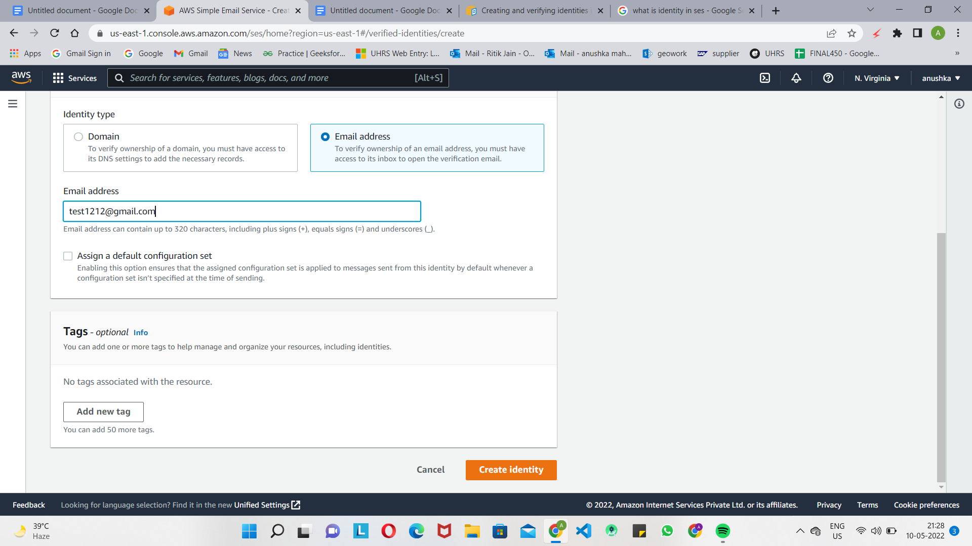

In this we will provide test email address in email address block and then click on **create identity.**

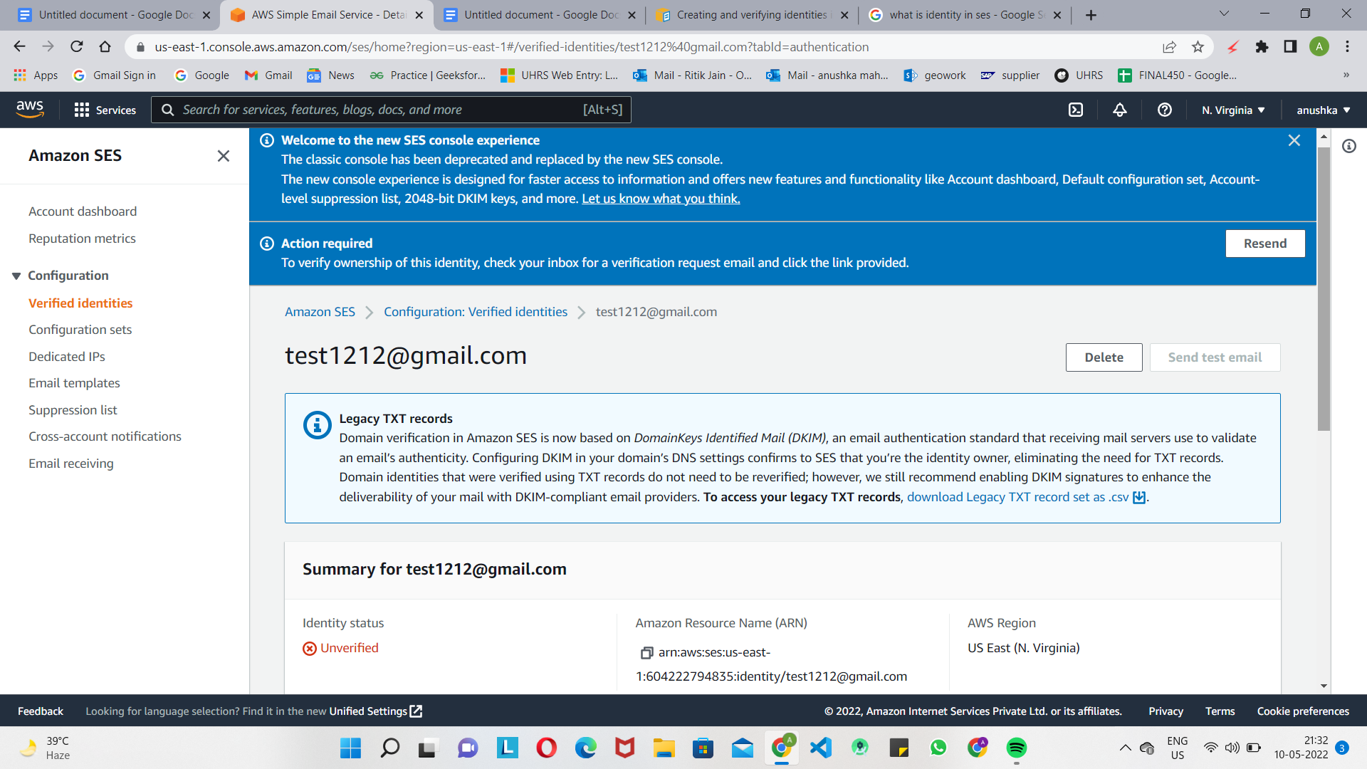

After creating an identity .We have to verify our test mail.

Similarly we will create multiple identities for sending and recieving mails.

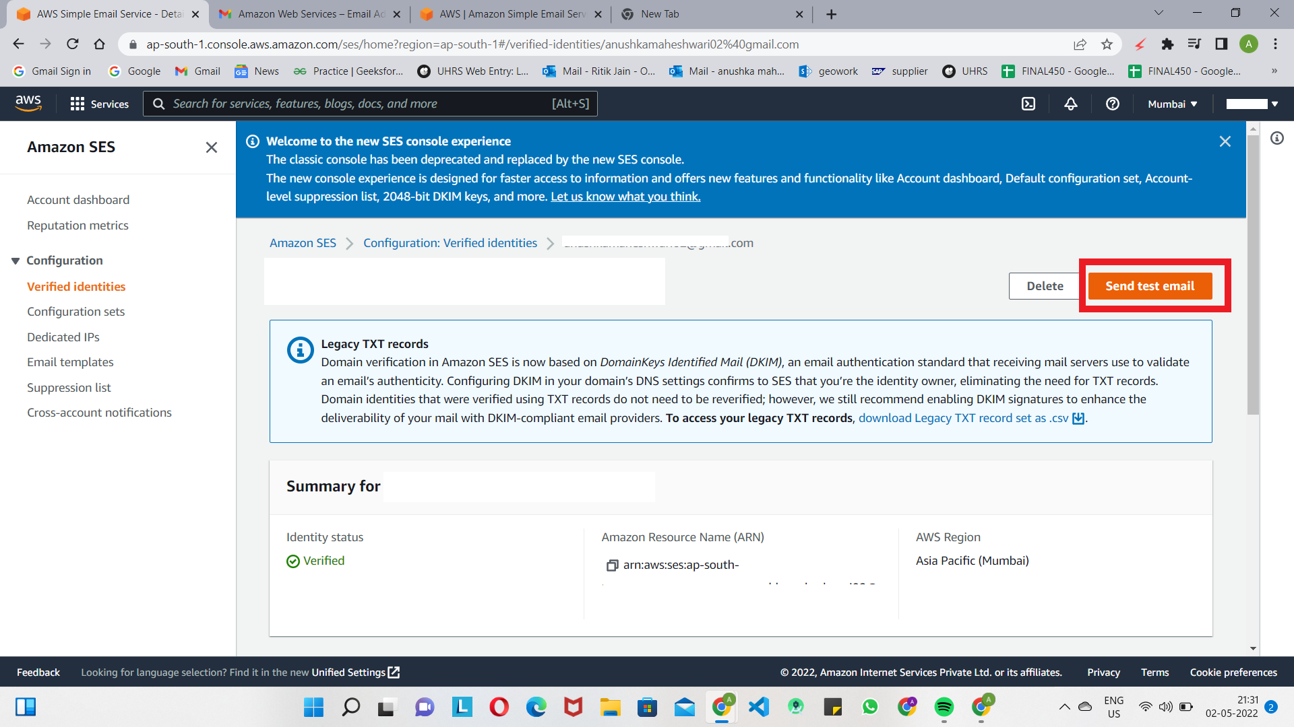

After creating multiple identities ,we will try to send the test emails from one identity to another identity.for this click on **send test email.**

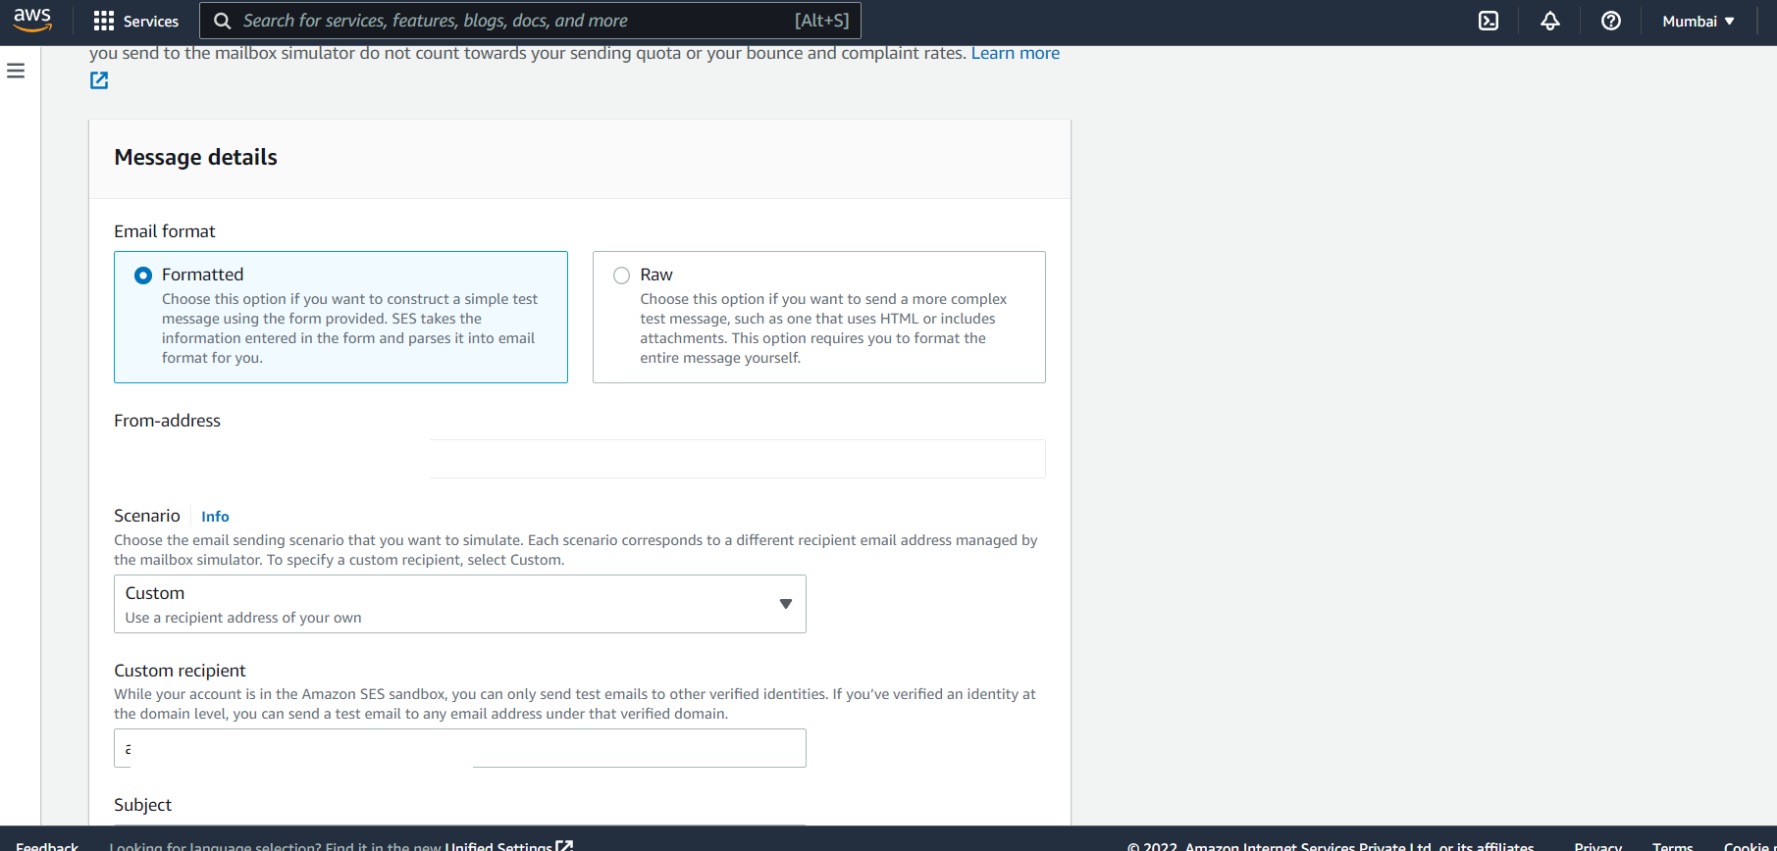

In message format options if we have only simple text then we have to select **Formatted**  option else if we have to send the JSON or HTML files we have use the **raw** option .

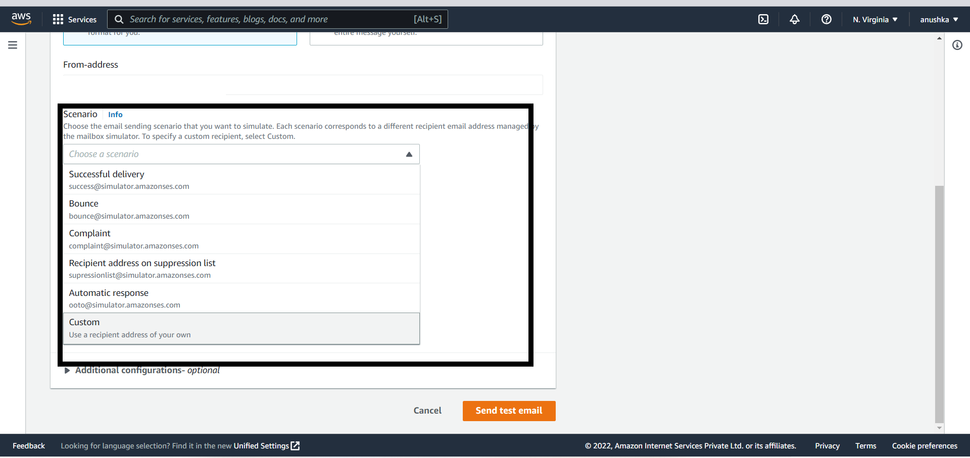

In scenerio select the type of email you want to send ,for the testing we would use **custom scenario.**

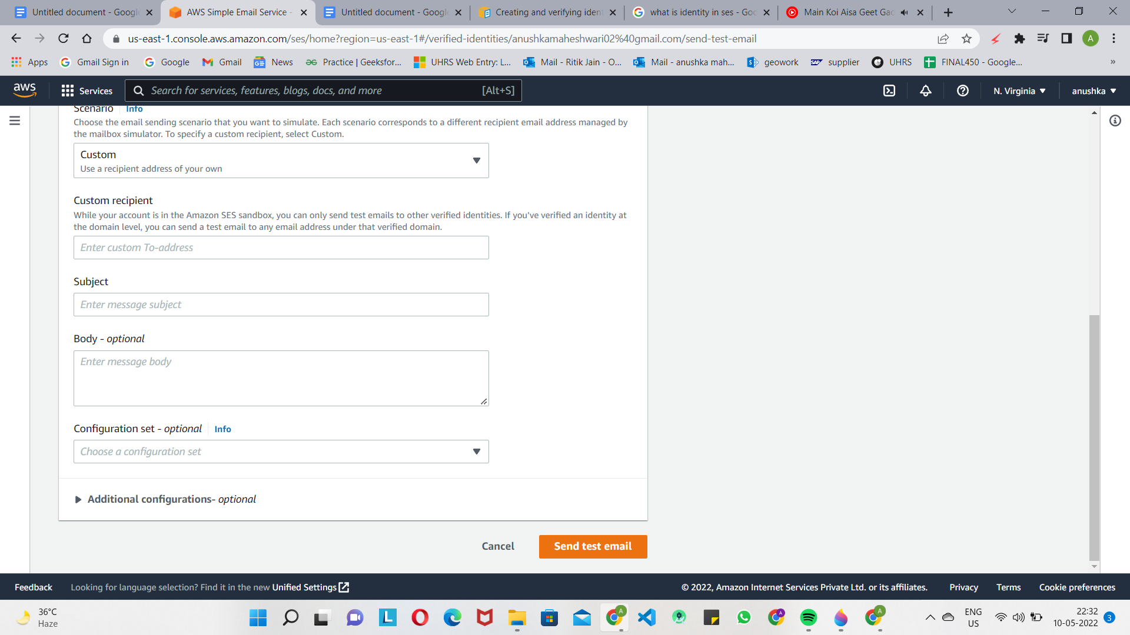

In custom recipient enter receiver mail address and fill subject and body respectively.

Click **send test email.**

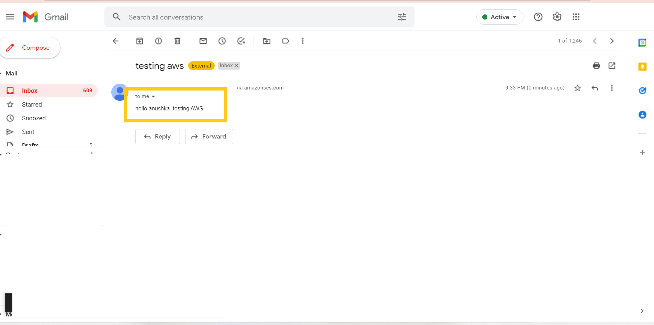Check the receiver's mail address **.BOOM !! your MAIL is received**

**“Thank you”**